> library(deSolve)
> library(dplyr)
> library(ggplot2)
> library(tidyr)
> library(purrr)
> library(ggpubr)
> ltg <- function(time, stocks, auxs){
+ with(as.list(c(stocks, auxs)),{
+ C <- P/K # Eq (2)
+ dP_dt <- r*P*(1-C) # Eq (1)
+ return (list(c(dP_dt),
+ r=r,
+ K=K,
+ C=C,
+ Flow=dP_dt))
+ })
+ }
> # Create a new "wrapper" function to parameterise each run
> run_scenario <- function(run_id=1,
+ P=100,
+ simtime=seq(0,100,by=0.25),
+ r=0.15,
+ K=100000){
+
+ auxs <- c(r=r,K=K)
+ stocks <- c(P=P)
+
+ res <- ode(y=stocks,
+ times=simtime,
+ func = ltg,
+ parms=auxs,
+ method="euler") %>%
+ data.frame() %>%
+ dplyr::as_tibble() %>%
+ dplyr::mutate(RunID=as.integer(run_id)) %>%
+ dplyr::select(RunID, everything())
+ }
> r_vals <- seq(0,.20,length.out=21)
> p_vals <- seq(0,1000,length.out=21)
> sim_inputs <- expand.grid(r_vals,p_vals)
> run_id <- 1
>
> sim_res <- map2(sim_inputs[,1],
+ sim_inputs[,2],~{
+ res <- run_scenario(run_id = run_id,
+ r = .x,
+ P = .y,
+ simtime = seq(0,100,by=0.25))
+ run_id <<- run_id + 1
+ res
+ }) %>% dplyr::bind_rows()
> sim_res
# A tibble: 176,841 × 7
RunID time P r K C Flow
<int> <dbl> <dbl> <dbl> <dbl> <dbl> <dbl>
1 1 0 0 0 100000 0 0
2 1 0.25 0 0 100000 0 0
3 1 0.5 0 0 100000 0 0
4 1 0.75 0 0 100000 0 0
5 1 1 0 0 100000 0 0
6 1 1.25 0 0 100000 0 0
7 1 1.5 0 0 100000 0 0
8 1 1.75 0 0 100000 0 0
9 1 2 0 0 100000 0 0
10 1 2.25 0 0 100000 0 0
# ℹ 176,831 more rows
# ℹ Use `print(n = ...)` to see more rows
> sum_vals <- sim_res %>%
+ dplyr::group_by(time) %>%
+ dplyr::summarize(MeanP=mean(P),
+ MedianP=median(P),
+ Q75=quantile(P,0.75),
+ Q25=quantile(P,0.25))
> sum_vals
# A tibble: 401 × 5
time MeanP MedianP Q75 Q25
<dbl> <dbl> <dbl> <dbl> <dbl>
1 0 500 500 750 250
2 0.25 512. 512. 778. 253.
3 0.5 525. 525. 803. 256.
4 0.75 539. 538. 818. 259.
5 1 552. 550 840. 263.
6 1.25 566. 564. 861. 266.
7 1.5 581. 577. 876. 269.
8 1.75 596. 591. 900 277.
9 2 612. 603. 920. 287.
10 2.25 628. 615. 941. 297.
# ℹ 391 more rows
# ℹ Use `print(n = ...)` to see more rows
> ggplot(sim_res,aes(x=time,y=P,color=RunID,group=RunID))+
+ geom_line()+
+ scale_color_gradientn(colors=rainbow(14))+
+ theme(legend.position = "none")+
+ labs(title="Population")+
+ theme(title = element_text(size=9))

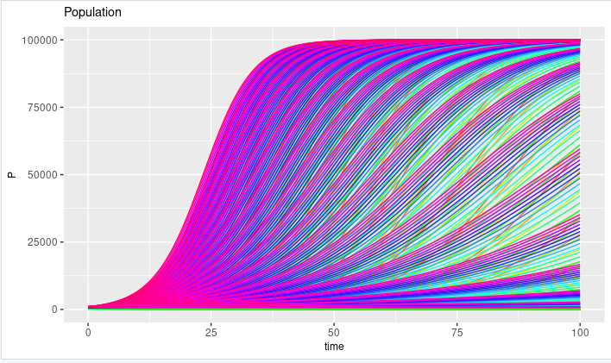

> ggplot(sum_vals,aes(x=time,y=MeanP))+geom_line()+
+ geom_line(aes(y=MedianP),colour="red")+
+ geom_ribbon(aes(x=time,ymin=Q25,ymax=Q75),
+ alpha=0.4,fill="steelblue2")+
+ labs(title="50% quantiles for population")+
+ theme(title = element_text(size=9))

